

SFC AUTO RENTAL / BELBOY SERVICES

1. **This Agreement** is between SFC AUTO RENTAL & (Renters Name) dgajhgakshgdgakdgkdskajd ooooou

Of Lot (Renters Address) jnkshalsdkhfkasjhdfkajdsfhaskdjffhaskdjfhadkfjfakjdfhakdsjfh. PHONE

Phone sufdhapisdufhpisadufposdihfposidfhaosdifhpasodf

2**. Car Detail**

YEAR:

MAKE:

MODEL :

PLATE # :

3. **Existing Damages:**

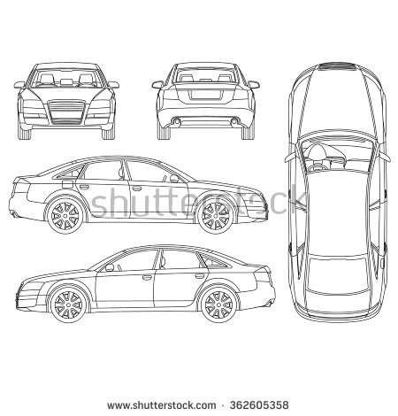

4. **PRE CHECK LIST:**

* CAR CLEAN INSIDE AND OUT
* START CAR
* WINDSHIELD & DOOR WINDOWS
* TRUNK, SPEAR TIRE & JACK
* CHECK HEADLIGHTS HI/LOW BEAM
* CHECK TURN SIGNALS L/R
* CHECK FOG LIGHTS
* CHECK BRAKES LIGHT

5. **PRE CHECK LIST CONT**. :

* CHECK WIPERS
* CHECK HORN
* CHECK RADIO
* CHECK A/C
* CHECK ALL 4 WINDOWS GOES UP & DOWN
* FOLD IN & OUT MIRRORS
* GAS LEVEL 1233 RRETURN AT SAME LEVEL FOR COMPLETE SECURITY DEPOSITE

1234

6. **RENTAL PERIOD:**

**FROM DATE/TIME TO DATE/TIME TOTAL DAYS TOTAL COST**

1212314141134122 QWFASDFSADF QERRQWER AFSDFASDF

7. **RENTAL FEE PER DAY**: **$ 7,000/$35USD INITIAL:2344**

8. **SECURITY DEPOSIT: $ 20,000/$100USD PAID 123 WAIVED 123 INITIAL:1234**

9. **COST DISCLOSURE:** As of today’s date, the full retail value of this car is $ 1,500,000

10. **DAMAGE OR LOSS:** The Renter is responsible for the risk of theft, damages, loss or destruction of the car from any and all causes. If the car in the possession of the Renter is damaged, the Renter agrees to pay for all repairs cost up to the current value of the car as stated in clause 9 above. If the car in the possession of the Renter is lost the Renter agrees to pay SFC Rental the full Value of the car stated in clause 9 above. **INITIAL: 1234**

10. **RULES OF USE:**

1. Renter must obey all traffic laws, regulations and speed limits.
2. Renter must not drive the car in their possession if under the influence of ANY DRUGS/ALCOHOL.
3. Renter must not sublease the car in their possession.
4. Renter agrees to no use the car for any illegal purposes.
5. Renter must be the only driver for the car unless stated elsewhere in the agreement

DRIVERS LICENSE NUMBER: 2143154513 EXPIRATION DATE222222222222

ADDITIONAL DRIVER LICENSE NUMBER: 2312312352 EXPIRATION DATE22222222222

1. RENTER MUST NOT DRIVE OFF ROAD WITH THE CAR IN THEIR POSSESSION ( BUSH,MADIAH, LETHEM) AND EVIDENCE OF OFF ROADING WILL RESULT IN FORFEITING SECURITY DEPOSITE.

Renter has inspected the car and agrees its in full working condition **INITIAL** 233343

RENTERS SIGNATURE:123134131112131314 DATE: 213423122342342341